### A CRM Application to Manage the Services offered by an Institution

## Project Overview

This Project is Focused On EduConsultPro Institute is a leading educational institution offering a variety of courses and programs in diverse fields. With a growing number of prospective students seeking admission each year, the institute faces challenges in managing the admission process, students enquiry, and expert consulting services efficiently. To address these challenges, EduConsultPro Institute decides to leverage Salesforce CRM to streamline the admission process and enhance the overall experience for both students and admissions staff.

The use case focuses on the admission process for prospective students interested in enrolling in courses and programs offered by EduConsultPro Institute. The goal is to provide a seamless and transparent experience for students while enabling admissions staff to efficiently review and process admission applications, students enquiry and case management.

# Objectives

**Admission Application Management:**  
Prospective students should have access to the admission application form through the institute's website or portal. The admission application form should collect comprehensive information including personal details, academic history, and qualification. Submitted admission applications should be captured and stored in the Salesforce CRM system. Students should receive automated email notifications after successful submission of application. Admissions staff should be able to generate reports and dashboards to analyze application metrics, acceptance rates, and enrollment trends.

**Approval Process Requirements :**Implement an Approval process in Salesforce to review and approve Consulting Request. Set up email alerts to notify relevant students when he/she is approved or rejected. Ensure that request gets automatically submitted when it is created.

**Consulting Services Management:**  
Prospective students should be able to request consulting services through the institute's website or portal. The consulting request form should capture student details, consulting preferences, and areas of expertise required. Submitted consulting requests should be recorded in the Salesforce CRM system. Consultants and advisors should receive automated email notifications for new consulting requests. Consultants should be able to view, accept, and manage consulting requests within the Salesforce CRM interface. Consulting appointment scheduling should be facilitated within Salesforce, including date, time, and purpose of the appointment. Appointment status (e.g., scheduled, completed, canceled) should be tracked and updated in Salesforce.

**Immigration Case Management:**  
Students should be able to initiate immigration cases through the phone, email or web. The immigration case submission form should capture case details, and relevant information. Submitted immigration cases should be recorded and stored in the Salesforce CRM system. Immigration agents and case managers should receive automated email notifications for new immigration cases. Immigration agents should be able to view, process, and track immigration cases within the Salesforce CRM interface. Case status (e.g., open, in progress, closed) should be tracked and updated in Salesforce. Document management and collaboration tools should be integrated to facilitate case processing and communication.

1. **Salesforce Key Features and Concepts Utilized**

**1. Lead and Opportunity Management**

Track potential clients (leads) and the progress of opportunities (sales or service engagements).

Helps institutions manage prospective clients and convert leads into long-term customers or users of services.

**2. Account and Contact Management**

Centralized database for storing and managing customer accounts and individual contacts.

Includes key details like customer preferences, service usage, and communication history.

**3. Service Cloud**

A dedicated suite for managing customer service and support operations.

Features case management, knowledge base, live chat, and automated workflows to provide seamless customer service.

**4. Customization and Automation**

Customizable dashboards and reports to track service performance and customer interactions.

Workflow automation (e.g., reminders, follow-ups) to improve operational efficiency.

**5. Case Management**

Track and resolve service-related issues or inquiries through case management.

Set up workflows for routing cases to the appropriate department or team member.

**6. Customer Self-Service Portals**

Allow customers to manage their own service requests or access information via self-service portals or knowledge bases.

Reduces the burden on customer service teams and enhances user experience.

**7**. **Integrated Communication Tools**

Tools for email, phone, chat, and social media communication, allowing seamless multi-channel communication.

Ensures consistent messaging and efficient communication across all touchpoints.

**8. Reports and Analytics**

Advanced reporting and analytics to measure customer satisfaction, service usage, and performance metrics.

Helps institutions track trends, identify bottlenecks, and make data-driven decisions.

**9. Mobile Access**

Mobile app for on-the-go access to customer information, case management, and service tasks.

Enables field agents or service providers to manage tasks remotely and efficiently.

**10. Collaboration Tools**

Chatter and other collaborative tools allow internal teams to share insights, updates, and customer-related information.

Enhances teamwork and improves service delivery across departments.

**11. Integration with Other Tools**

Integration with third-party applications and systems (e.g., ERP, marketing tools) to provide a unified view of customer data.

Ensures seamless workflows between various departments and systems.

**12. AI and Machine Learning (Einstein)**

Salesforce Einstein offers AI-driven insights and predictive analytics for personalized customer service, forecasting, and automation.

Helps in identifying customer needs proactively and delivering tailored services.

**13. Customer Feedback and Surveys**

Tools for gathering and analyzing customer feedback, ensuring continuous service improvement.

Helps measure customer satisfaction and adjust services based on feedback.

By leveraging these features, Salesforce helps institutions optimize service delivery, improve customer relationships, and boost operational efficiency.

# 4.Detailed Steps to Solution Design

Designing a CRM solution with Salesforce to manage the services offered by an institution involves several structured steps to ensure the solution meets the institution's needs while aligning with best practices. Below are the detailed steps for solution design:

**1. Understand Business Requirements**

Stakeholder Interviews: Conduct interviews with key stakeholders (e.g., service managers, customer support, sales, marketing) to understand their processes, pain points, and goals.

**Define Key Services:** Understand the specific services that the institution offers (e.g., consulting, training, customer support) and how they interact with customers.

**Identify Key User Groups:** Identify the different user types (e.g., admin, customer service reps, sales reps) and their roles within the CRM.

**Service Lifecycle Mapping:** Map the lifecycle of each service from initial inquiry through service delivery, support, and follow-up.

**2. Define the Data Model**

**Objects and Fields:** Define custom objects (e.g., Service Requests, Contracts, Service Plans) and fields needed to capture data relevant to the institution's services.For example, if the institution offers educational programs, you might need custom objects for courses, enrollment details, and schedules.

**Relationships:** Define relationships between standard Salesforce objects (Accounts, Contacts, Opportunities) and custom objects.For example, an Account (institutional client) can be linked to multiple Service Requests, Cases, or Contracts.

**Data Schema:** Develop a schema diagram to visualize the relationships between objects and data flow. Ensure there is a clear understanding of how data will be.

# Testing and Validation

# 1. Test Plan Creation

# Define Scope: Determine the areas to be tested, such as lead management, opportunity tracking

# case handling, student enrollment, communications, and reporting.

# Test Objectives: Set clear objectives, e.g., validating that all data is correctly captured, workflows

# trigger as expected, and users can navigate the system efficiently.

# Test Scenarios: Outline the test scenarios based on real-world use cases. These might include:

# Creating and tracking leads and opportunities.

# 

# Managing student queries and cases.

# Processing enrollments and course assignments.

# Generating and viewing reports.

# 2. Types of Testing

# a) Functional Testing

# Ensure that all CRM features (lead management, student registration, case management, etc.) are working as expected.

# b) User Interface (UI) Testing

# Objective: Ensure the CRM interface is intuitive and user-friendly.

# Testing Scenarios:

# Ensure that users can easily navigate between modules (e.g., Leads, Cases, Opportunities).

# Test for responsive design on mobile and desktop versions.

# Validate that custom fields and components are displaying properly.

# c) Integration Testing

# Objective: Verify that Salesforce integrates smoothly with other third-party systems.

# Examples:

# Ensure proper data flow between Salesforce and the institution's student information system (SIS) or learning management system (LMS).

# Validate integrations with email platforms (e.g., Gmail, Outlook), payment gateways, and other external tools.

# Test API connections if integrating Salesforce with external systems like accounting software or marketing platforms.

# d) Workflow Testing

# Objective: Verify that Salesforce workflows, processes, and automation (e.g., Process Builder, Flow) work correctly.

# Examples:

# Test whether automatic lead assignment based on criteria (e.g., location, interest) is functioning properly.

# Validate approval processes for student enrollments or fee payments.

# Test approval and rejection flows for applications, ensuring appropriate notifications are triggered.

# e) Security Testing

# Objective: Ensure that Salesforce security features are properly configured and data is protected.

# Examples:

# Test role-based access control (RBAC) to verify that users have appropriate access to records (e.g., admin, consultant, student).

# Ensure that sensitive student data is encrypted and only accessible by authorized personnel.

# Validate two-factor authentication (2FA) and single sign-on (SSO) configurations.

# f) Performance Testing

# Objective: Test how the CRM performs under load, especially during peak usage times.

# Examples:

# Simulate multiple users accessing the system simultaneously to ensure the CRM doesn't slow down.

# Test data loading times for reports, dashboards, and student records.

# g) Regression Testing

# Objective: Ensure that new features or updates do not negatively impact existing functionality.

## Key Scenarios Addressed by Salesforce in the Implementation Project

## 1. Lead and Opportunity Management

## Scenario: Managing prospective students or clients (leads) through the sales funnel. Salesforce’s Lead Management feature helps track and nurture leads from initial inquiry to enrollment.

# 2. Student and Course Enrollment Management

# Scenario: Tracking student interest, applications, and enrollments for courses and programs offered by the institution.

# Salesforce Solution: Use Custom Objects to track detailed student information, cours preferences, and enrollment status.

# 3. Case Management for Student Support

# Scenario: Managing student queries, support tickets, or requests for assistance throughout the

# application or enrollment process.

# Salesforce Solution: Service Cloud enables case management, where student inquiries (e.g., about documents, deadlines, application status) are logged, tracked, and resolved efficiently.

# 4. Consultant and Staff Workflow Automation

# Scenario: Streamlining internal processes for education consultants and administrative staff handling student admissions, document verification, and communication.

# Salesforce Solution: Process Builder or Flow can automate key tasks, such as:

# Automatically assigning leads to consultants based on predefined criteria (e.g., location, interest in a specific course).

# Creating follow-up tasks or reminders for consultants to contact prospective students or review their documents.

# Sending automated emails to students regarding their application status, reminders for document submission, or upcoming deadlines.

# 5. Student Communication and Engagement

# Scenario: Ensuring consistent communication with students and parents throughout their journey (pre-enrollment, enrollment, post-enrollment).

# Salesforce Solution: Salesforce Marketing Cloud or Pardot can be used to create personalized email campaigns to engage students at various stages of the process.

# Automation of emails for updates, reminders, and personalized recommendations based on students' behavior or progress.

# Chatter enables real-time communication between staff members to collaborate on student queries, keeping all relevant parties in the loop.

# 6. Tracking and Managing Payment and Billing

# Scenario: Handling payments, fees, and billing for student enrollments and services.

# Salesforce Solution: Custom Payment Tracking objects can be created to track fee payments, payment plans, and status (e.g., pending, completed).

# Salesforce integrates with payment gateways to record payments and link them to student accounts.

# Conclusion

The implementation of a CRM application on the Salesforce platform will transform mall management by providing a comprehensive, integrated solution for sales, customer service, and marketing. By centralizing data, automating processes, and leveraging advanced analytics, the CRM will enhance operational efficiency, improve tenant and customer satisfaction, and drive revenue growth. This project will serve as a benchmark for future technology-driven initiatives in mall management, setting new standards for excellence and innovation.

The CRM application will not only streamline operations but also provide a seamless and efficient management experience. By integrating all aspects of mall operations into a single platform, the CRM application will empower mall management to make informed decisions, improve strategic planning, and enhance overall efficiency.

# Overall, implementing Salesforce as a CRM solution is a strategic investment for any institution

# aiming to optimize its service offerings and improve overall service delivery.

# Output:

# PICTURE 1:

# 

# PICTURE 2:

# 

**PICTURE 3:**

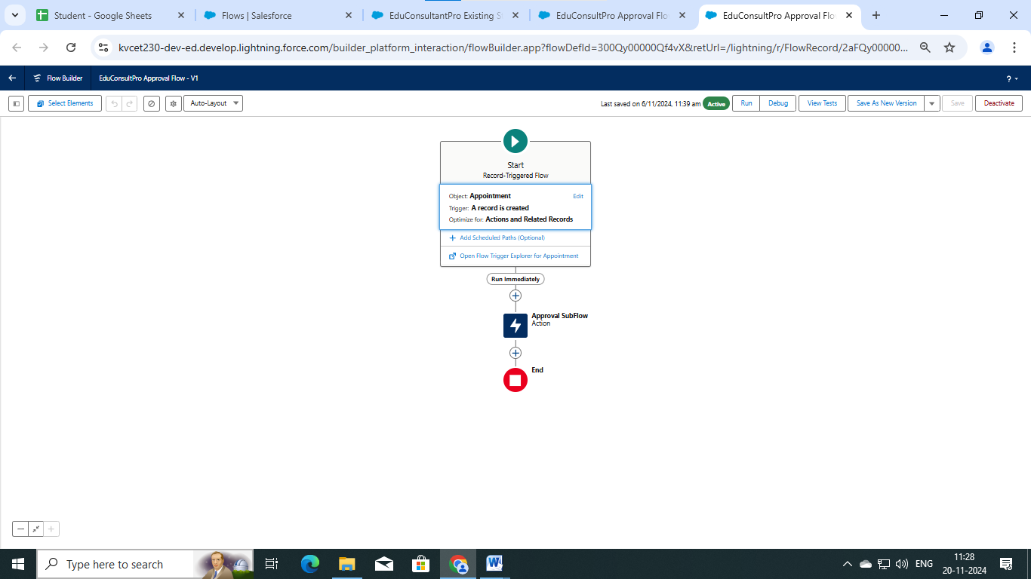

**PICTURE 4:**

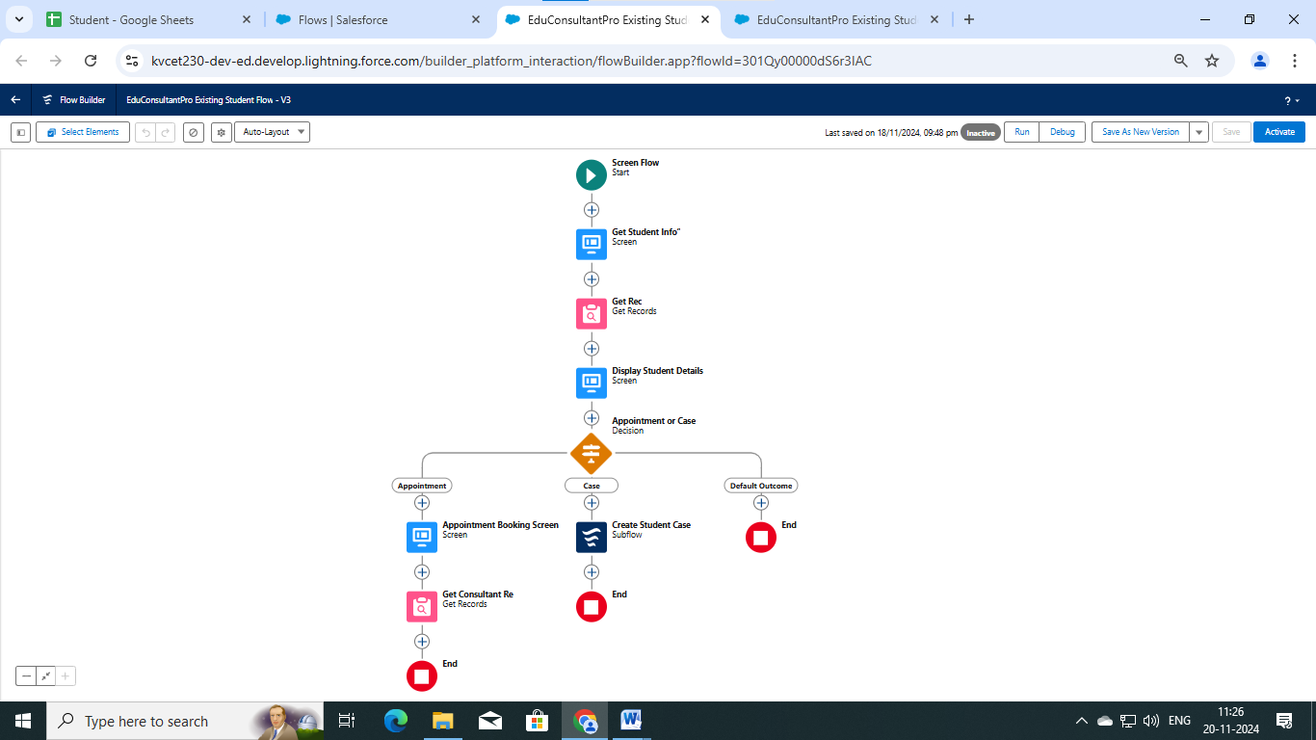

**PICTURE 5:**

